AWS Cloud EC2 Tasks

- Launch one EC2 using Amazon Linux 2 image and add a script in user data to install Apache.

Steps:
    - Login to AWS account logon as a root user
    - Open EC2 Dashboard Launch instances
    - Name the instance My-Apache-server
    - Select AMI Amazon Linux 2023
    - Instance type t3.micro
    - Key_pair linux_testing.pem (existing)
    - Network settings Security groups Inbound rules Allow all traffic & Outbound rules Allow all traffic
    - Advanced settings Add user data script
#!/bin/bash
Sudo yum install httpd -y
Sudo systemctl start httpd
Sudo systemctl enable httpd
echo “Hello installed using user data" > /var/www/html/index.html
    - Launch instance Click Launch instance & to wait till it is running.
    - SSH connect ssh -i key.pem ec2-user@<EC2-PUBLIC-IP>
    - Verify httpd status systemctl status httpd
    - Access website in browser http://<EC2-PUBLIC-IP>
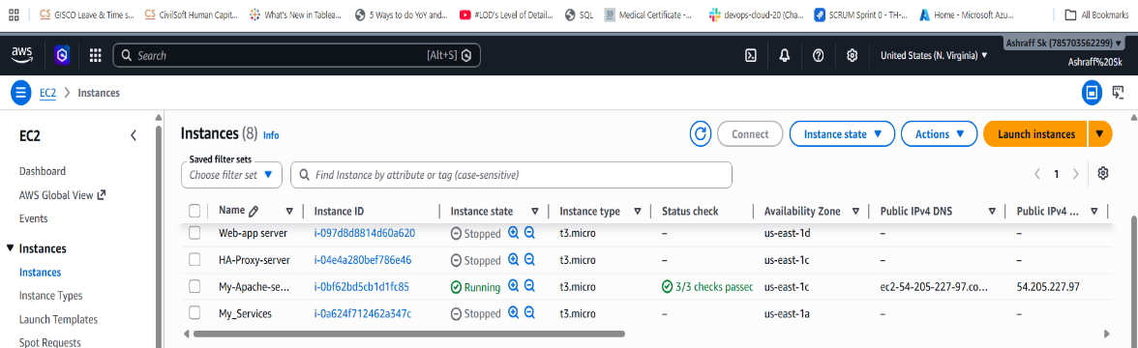
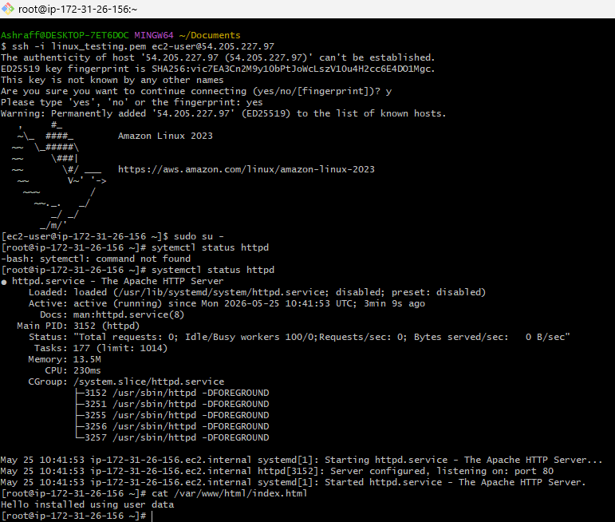
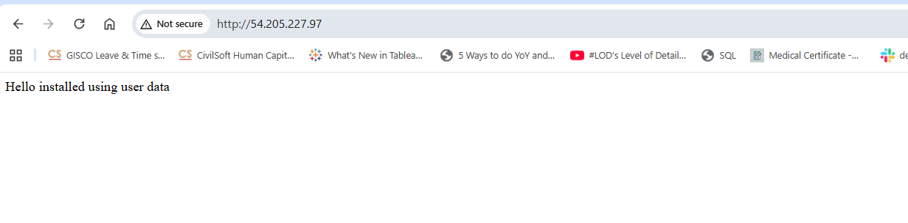

- Launch one EC2 using Ubuntu image and add a script in user data to install Nginx.
Steps:
    - Login to AWS account login as a root user.
    - Open EC2 Dashboard Launch instances
    - Name the instance My-ubuntu-nginx-server
    - Select AMI Ubuntu Server 26.04 LTS
    - Instance type t3.micro
    - Key_pair linux_testing.pem (existing)
    - Network settings Security groups Inbound rules Allow all traffic & Outbound rules Allow all traffic
    - Advanced settings Add user data script
#!/bin/bash
Sudo apt update -y
Sudo apt install nginx -y
Sudo systemctl start nginx
Sudo systemctl enable nginx
echo “Installed nginx using user data on ubuntu Ec2 " > /var/www/html/index.html
    - Launch instance Click Launch instance & to wait till it is running.
    - SSH connect ssh -i key.pem ubuntu@<EC2-PUBLIC-IP>
    - Verify nginx status systemctl status nginx
    - Access website in browser http://<EC2-PUBLIC-IP>
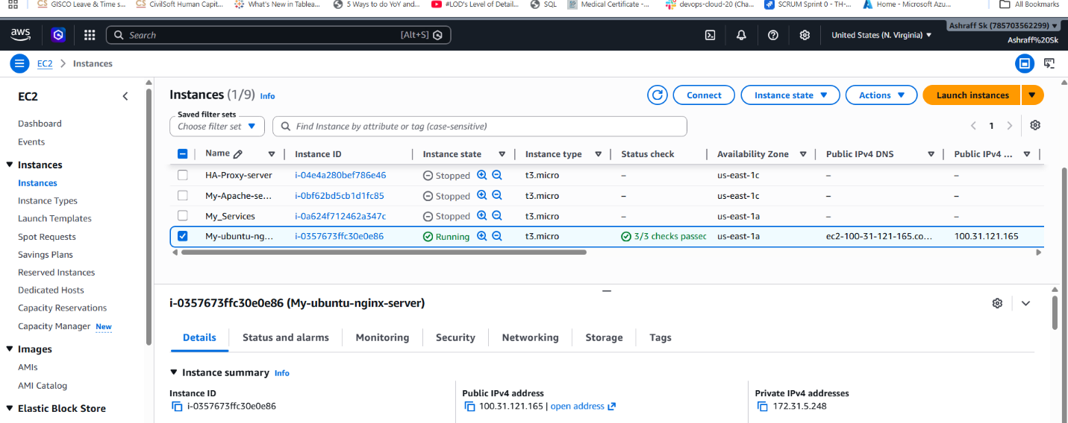

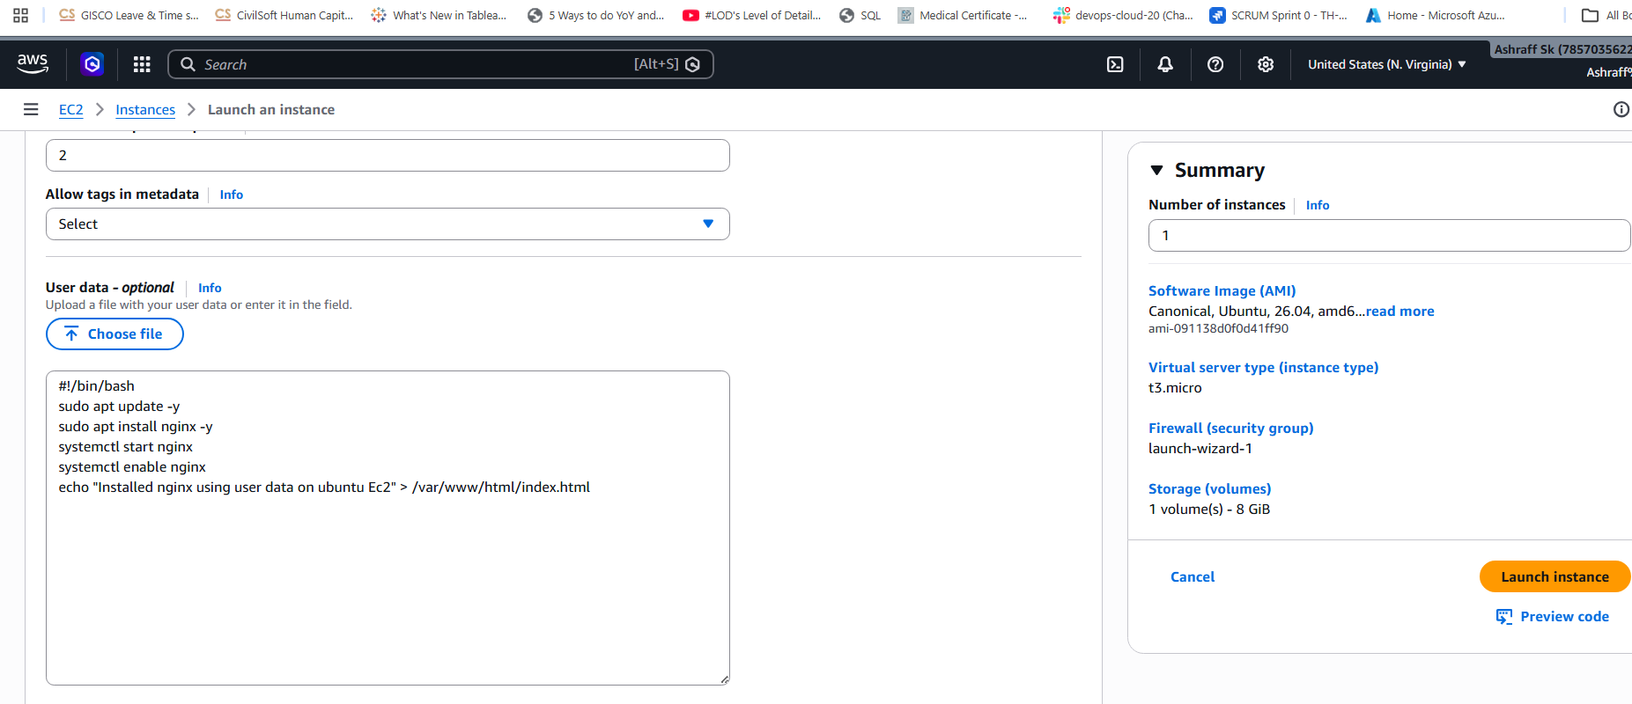
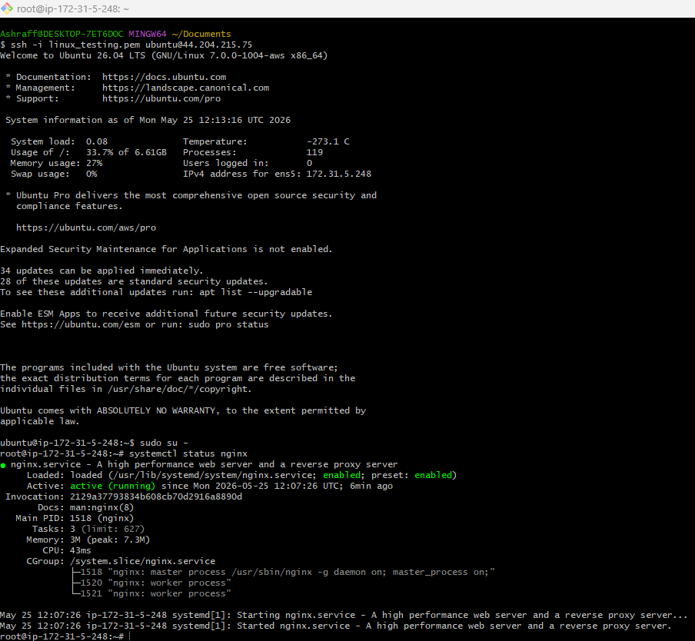
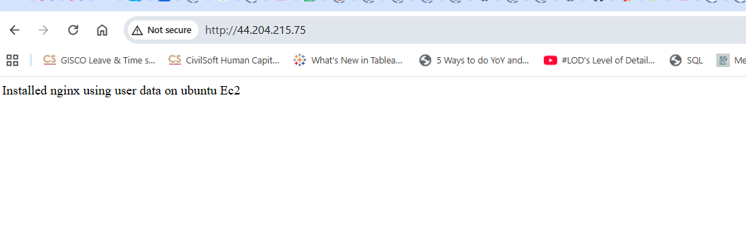
- Launch one Windows server and install Tomcat on Windows.

Pre-requisite : We need java to install Tomcat
Steps:
    - Login to AWS account login as a root user.
    - Open EC2 Dashboard Launch instances
    - Name the instance Tomcat-windows-server
    - AMI Microsoft Windows Server 2022
    - Instance type t3.micro
    - Key_pair linux_testing.pem (existing)
    - Network settings Security groups Inbound rules Allow all traffic & Outbound rules Allow all traffic
    - Launch instance Click Launch instance & to wait till it is running.
    - Connect to Windows Server Select instance & Click
        - select:
RDP Client
- Get Administrator Password
        - Click:
        - Get Password
        - Upload:
        - Linux_testing.pem
        - Decrypt password.
- Login to Windows Server
  - Username: Administrator
  - Password:(decrypted password)
- Download & install Java 17
- Configure JAVA_HOME
  - Variable Name: JAVA_HOME
  - Variable path: C:\Program Files\Java\jdk-17
- Open browser in Windows server.
  - To Verify Java
  - Open Command Prompt:
  - java --version
  - Expected output: java 17
- Download Apache Tomcat 9 windows zip
  - Extract to: C:\Tomcat9
- In command prompt cd C:\Tomcat9\bin
- Run startup.bat
- To verify open browser:
http://localhost:8080

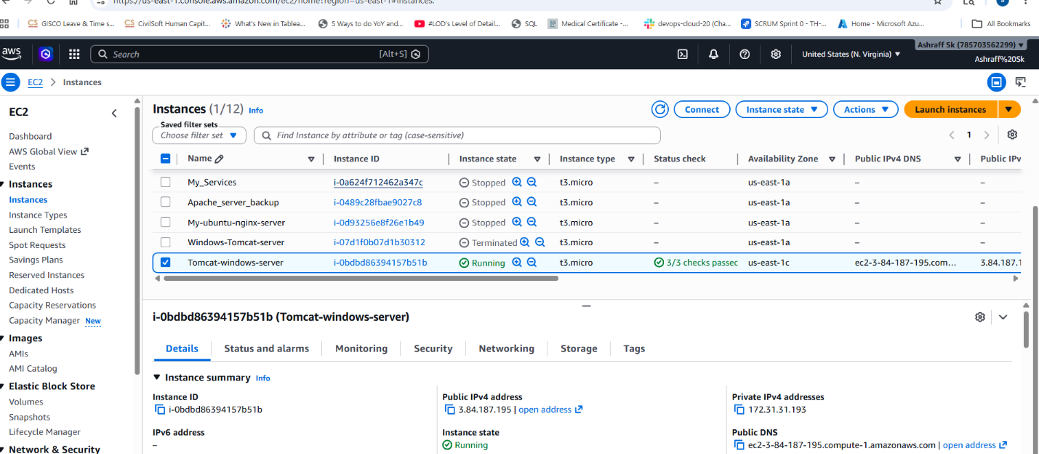

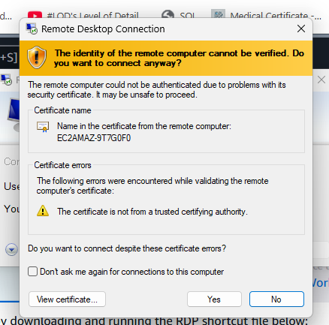

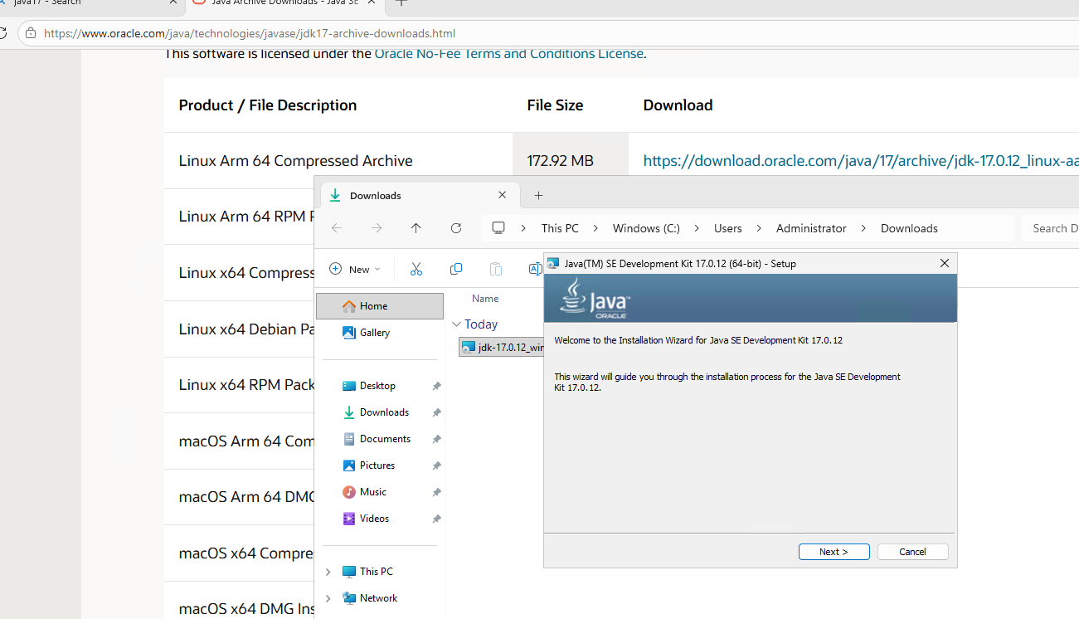

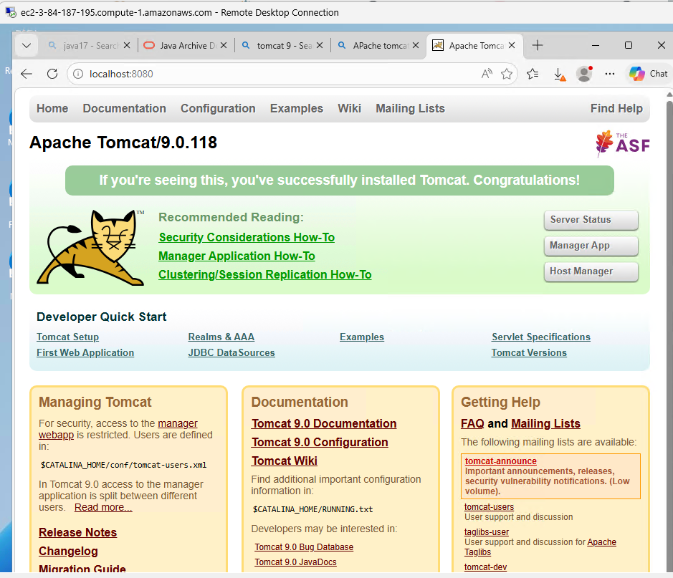

- Take a snapshot of the instance created in Task 1.

Prerequisite:
Task 1 instance to be in running state
Steps:

    - Login to AWS account login as a root user.
    - Open EC2 Dashboard Click on My-Apache-Server instance
    - Create Image Select the instance Actions Image and Templates Create Image
    - Image details Name: First_apache_server_backup
    - Check Image Images AMIS
    - Open Amazon Machine Images (AMIs) First_apache_server_backup AMI created
    - Create instance Apache_server_backup
    - Instance type t3.micro
    - Select AMI My AMIs select First_apache_server_backup
    - Create Key_pair Name as backup_keyserver
Key_pair type RSA
Private key file format .pem
    - Network settings Security groups Inbound rules Allow all traffic
    - Launch instance Click Launch instance & to wait till it is running.
    - SSH connect ssh -i backup_keyserver.pem ec2-user@<EC2-PUBLIC-IP>
    - Verify httpd status systemctl status httpd
    - Read the content Cat /var/www/html/index.html
    - Access website in browser http://<EC2-PUBLIC-IP>

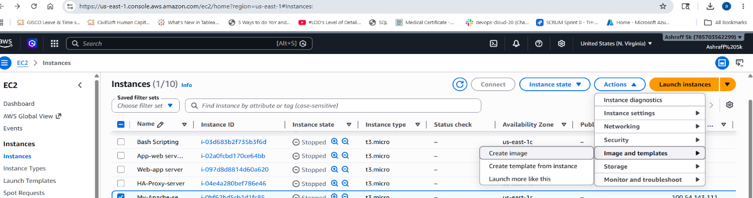

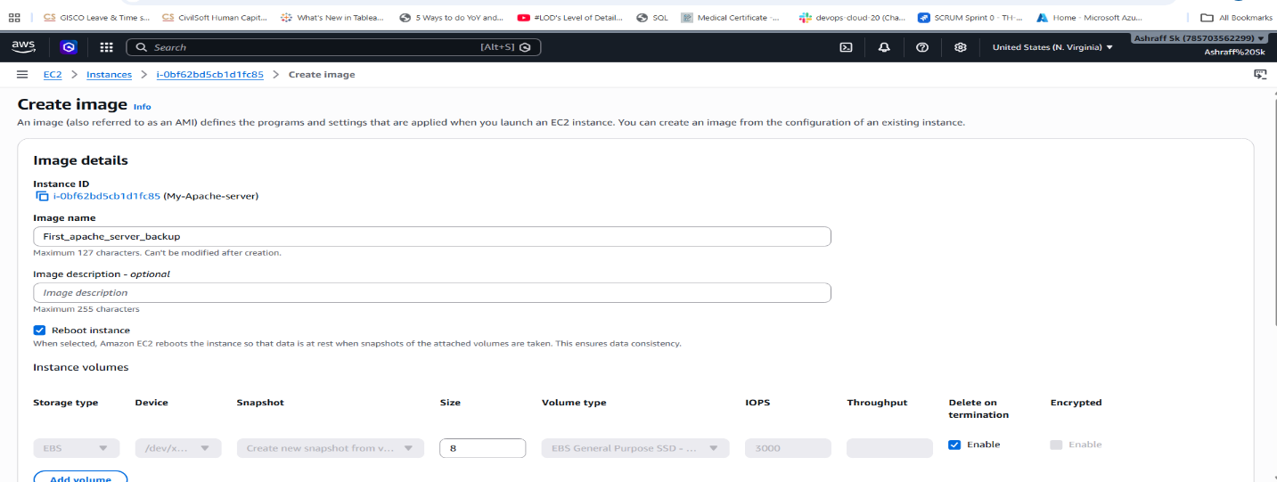
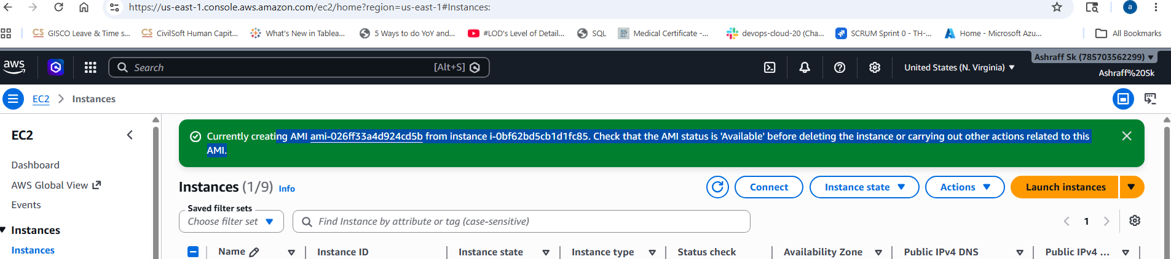

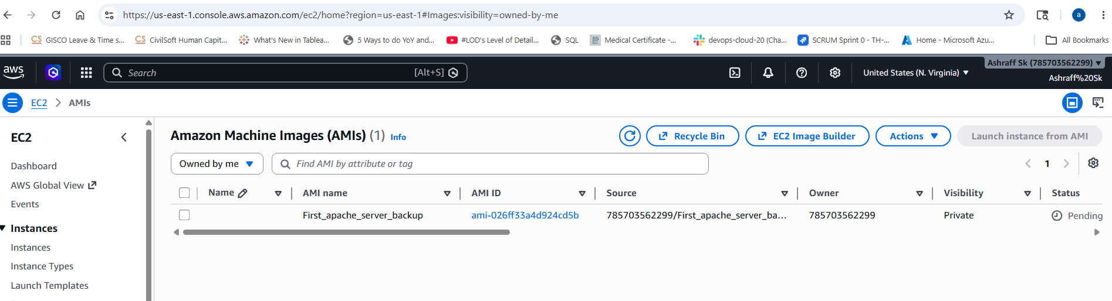
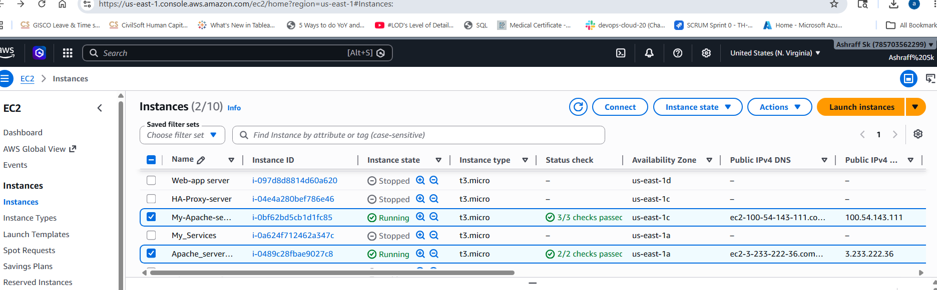
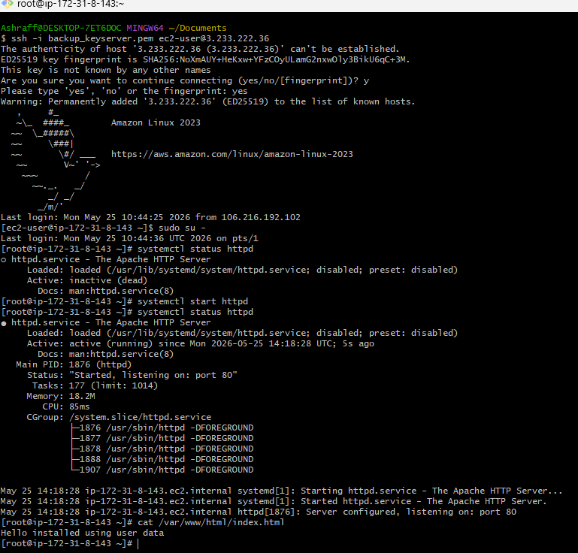

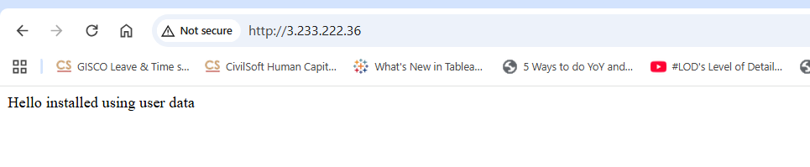
Conclusion: Taking a snapshot of an EC2 instance creates a point-in-time, incremental block-level backup of its attached Amazon EBS volumes. Its primary purpose is disaster recovery, data protection, and establishing easily deployable configuration baselines

- Assign password less authentication for the EC2 created in Task 2.

Steps:
    - Login to AWS account login as a root user.
    - Open EC2 Dashboard Click on My-ubuntu-nginx-server instance
    - Create a ssh-key from Git bash ssh-keygen
    - Copy the public key cat: /c/Users/Ashraff/.ssh/id_rsa_pub:
    - Connect to ec2 instance: ssh -I <pem_key> ubuntu@ <public ipv4>
    - Add the ssh public key cd /.ssh vi authorization_keys paste the ssh public key & save
    - Now exit from the server exit
    - Access the ec2 instance without pem key ssh -I ubuntu@ 3.239.44.163
    - Now we are able to establish the connection without pem key using password less authentication.
Conclusion: This method bypasses password prompts by authenticating using a cryptographic key pair (.pem or .pub files)

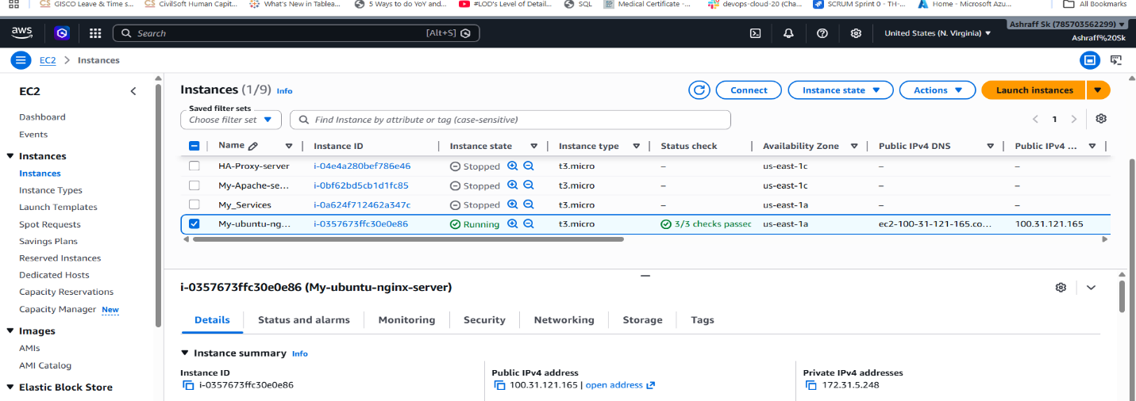

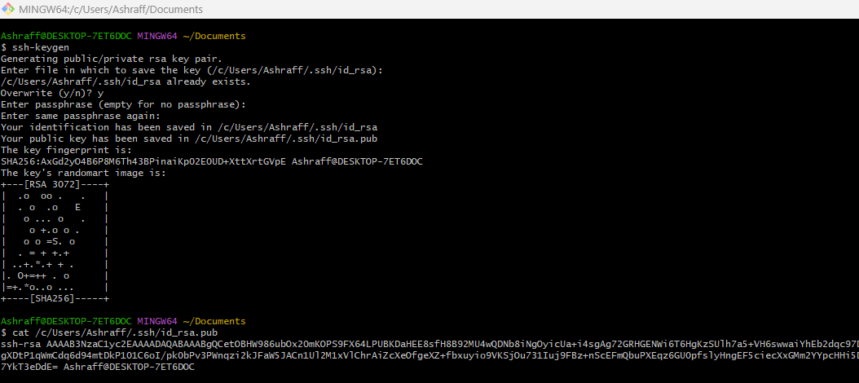
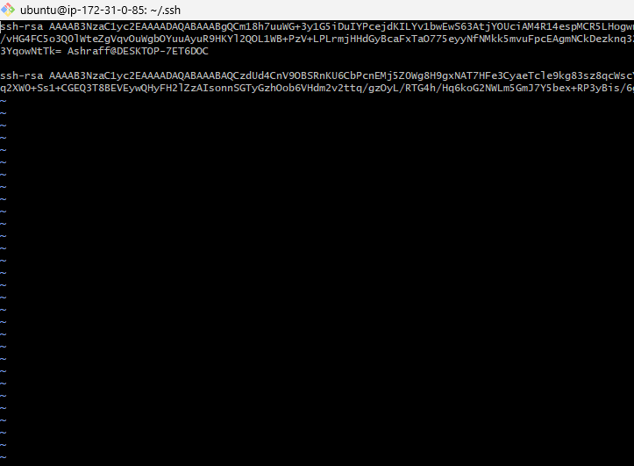

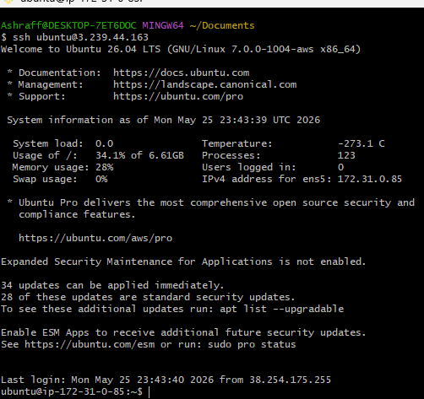

- Launch any EC2 using the spot purchasing option.

Purpose: The primary purpose of an Amazon EC2 Spot Instance is to dramatically cut cloud computing costs by utilizing AWS's spare compute capacity at discounts of up to 90% off standard On-Demand prices

Steps:
    - Launch EC2
    - Advanced Details → Enable "Request Spot Instances"
    - Set max price
    - Complete launch Validation In EC2Console
    - Instance details
    - Lifecycle = spot is visible Key

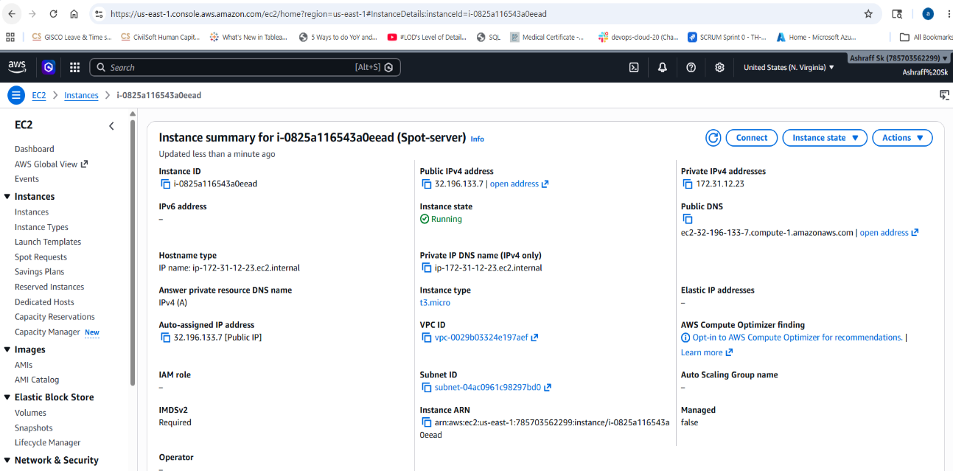
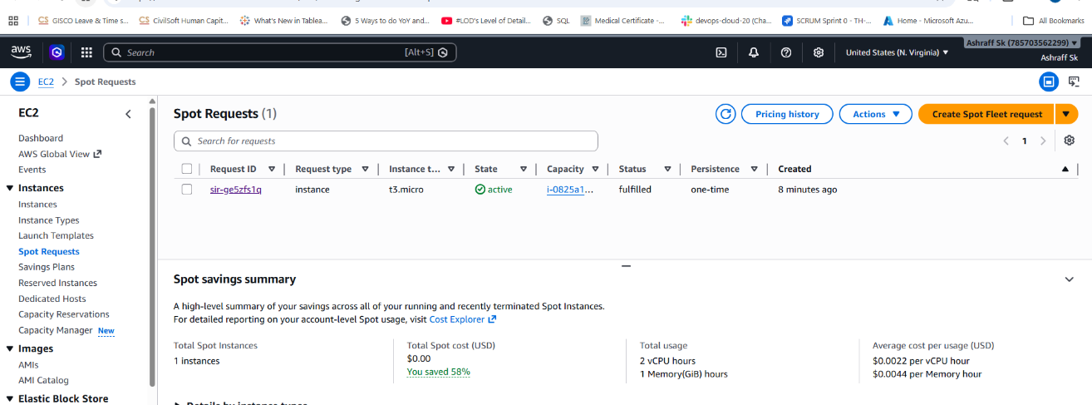

Conclusion: These instances are ideal for workloads that are flexible, stateless, or fault-tolerant. Because AWS can interrupt your Spot Instance with a 2-minute warning when it needs the capacity back, they are not suited for traditional, uninterrupted applications.

- Enable termination policy on the EC2 created in Task 2.
Purpose: Enabling EC2 Termination Protection prevents accidental deletion of your instances by blocking terminate commands from the AWS Console, CLI, and API
Steps:
    - Login to AWS account login as a root user.
    - Open EC2 Dashboard Click on My-ubuntu-nginx-server instance
    - Open Instance Settings Actions Instance Settings Change Termination Protection
    - Enable Protection Enable ✅
    - Then Save & a popup is displayed that Termination Protection is enabled.
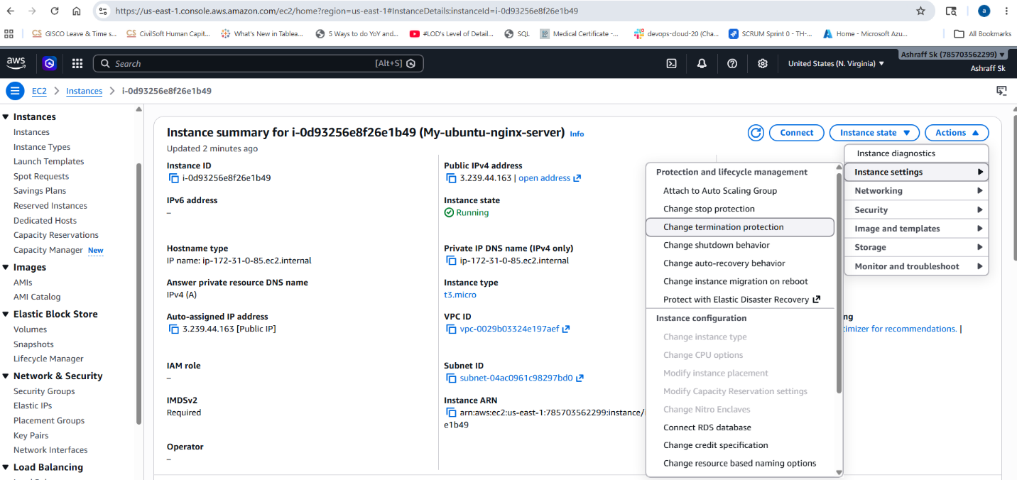

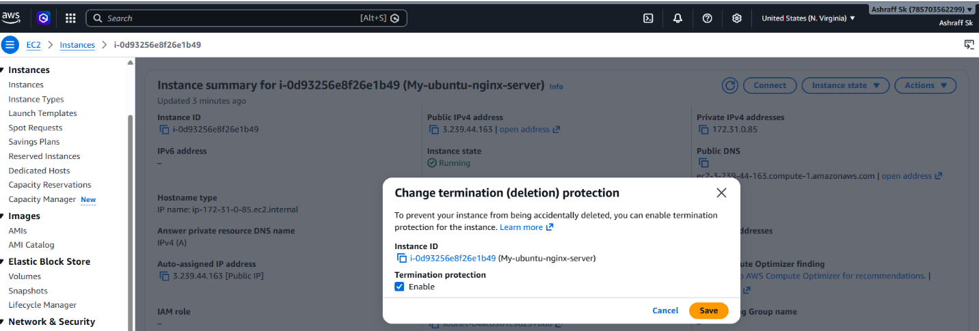
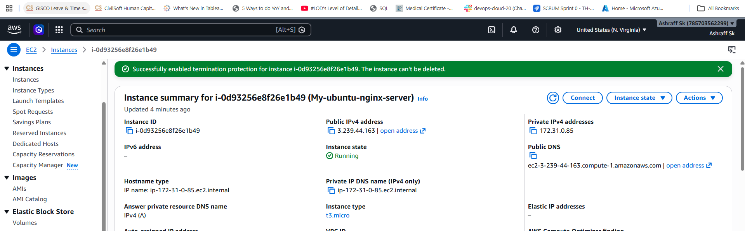

Conclusion: By enabling the Termination Protection on an Amazon EC2 instance, you can use the AWS Management Console or the AWS CLI. This safeguard prevents accidental deletion but allows you to stop and start the instance normally

- Launch one EC2 using AWS CLI.

Prerequisites:
Installed AWS CLI, IAM user, aws configure done with Access Key & Secret
Key with Region, existing Key pair name and Security Group ID.

Steps:
- Create a one IAM user
- Generate a Access key & secret key
- Check for aws cli in command prompt & Install aws CLI in local machine
- open command prompt of our local machine
and search for the aws --version.
- configure aws configure
- Enter the Access key and secret access key
- Enter aws ec2 describe-key-pairs to list the exact names of security keys registered in your region
- Executed the aws ec2 run-instances command
  - aws ec2 run-instances ^
  - --image-id ami-026ff33a4d924cd5b ^
  - --count 1 ^
  - --instance-type t3.micro ^
  - --key-name backup_keyserver ^
  - --security-group-ids sg-02d6ff42723b515ec ^
  - --subnet-id subnet-04ac0961c98297bd0

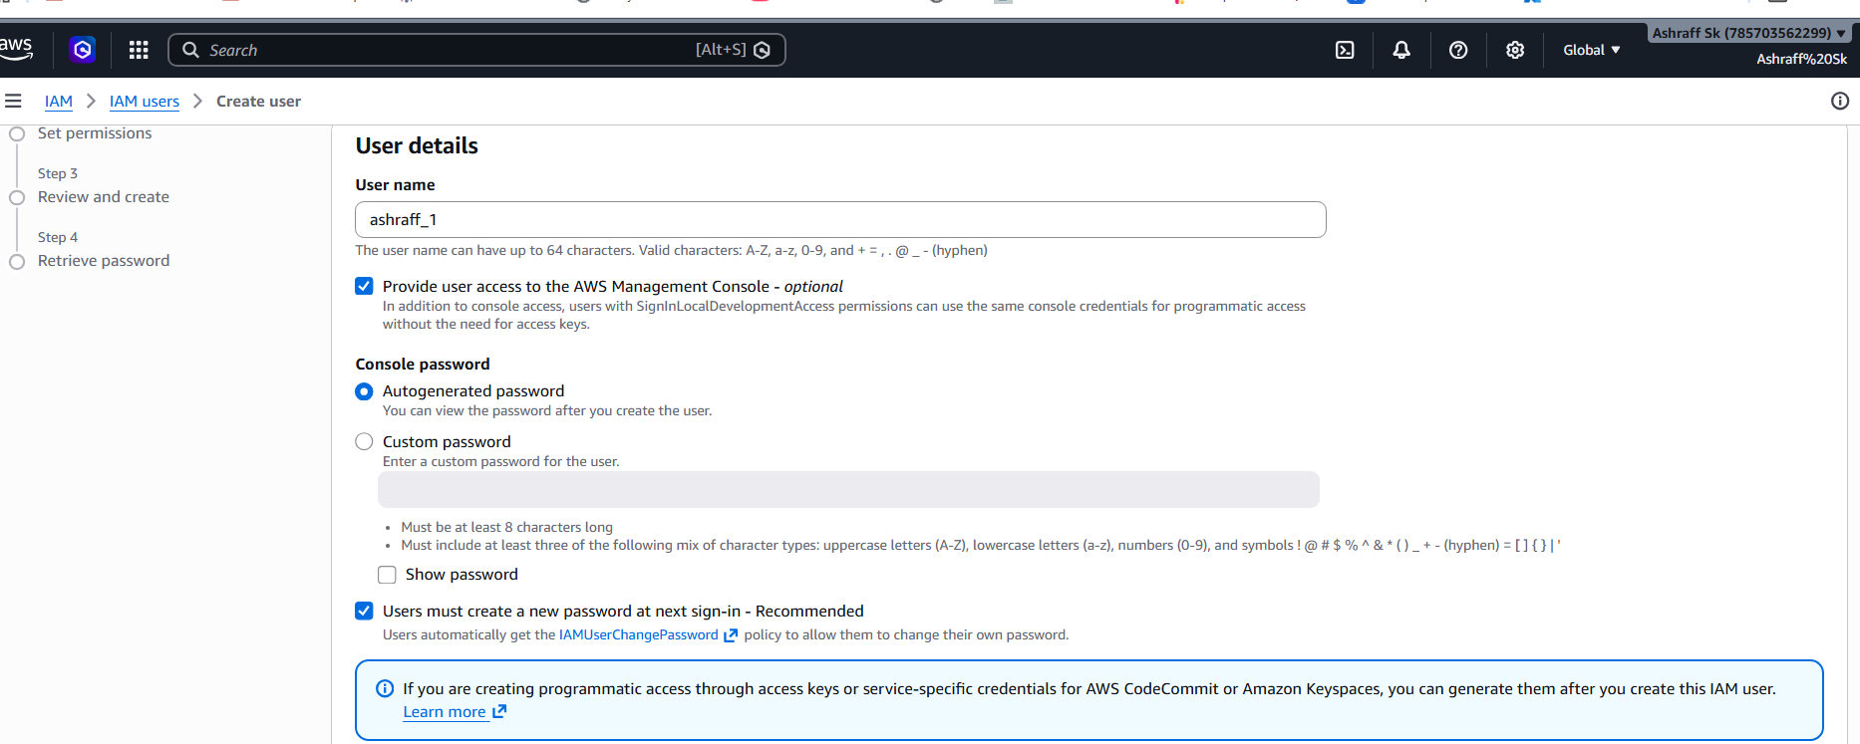

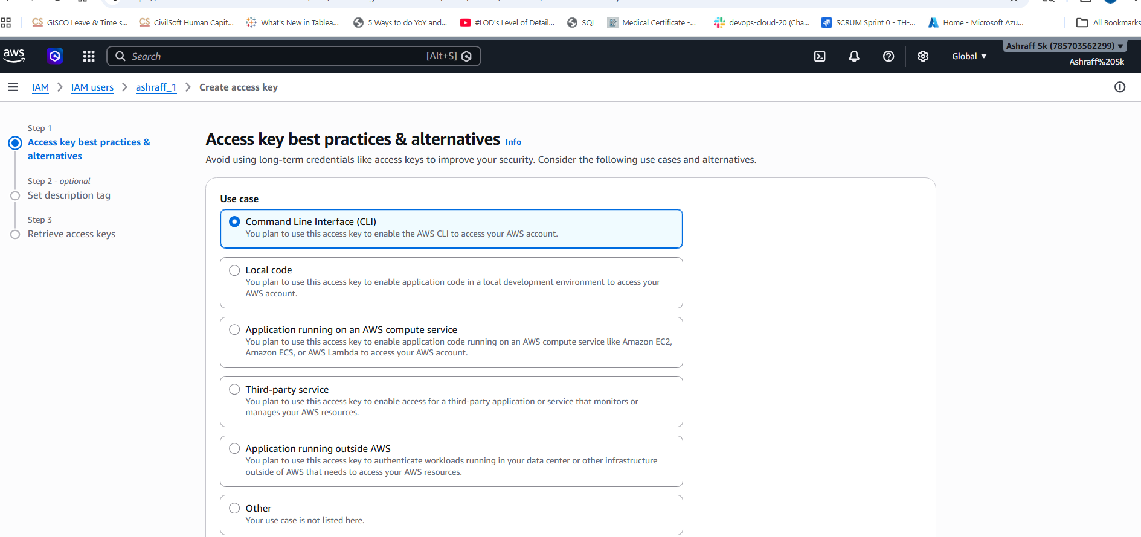

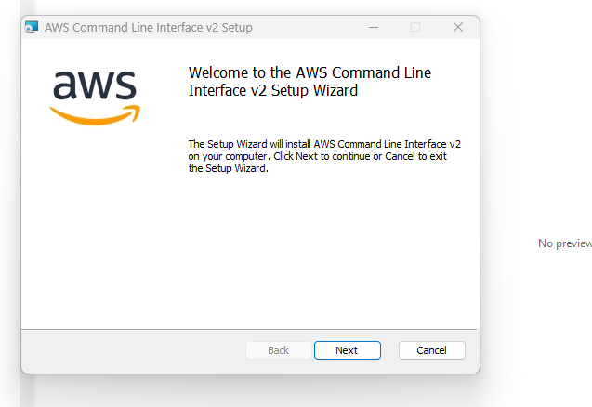

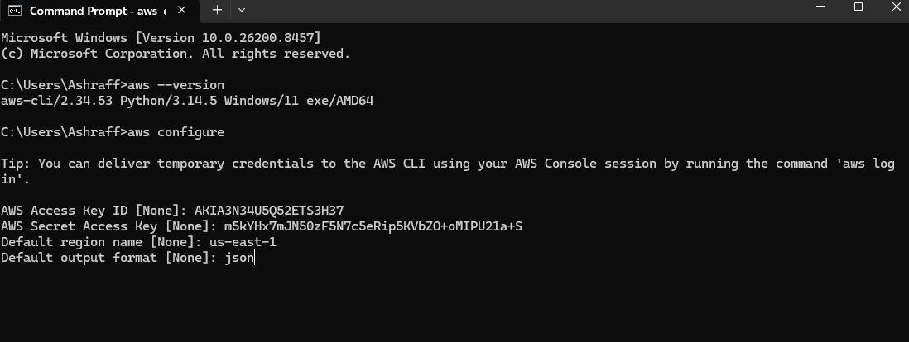
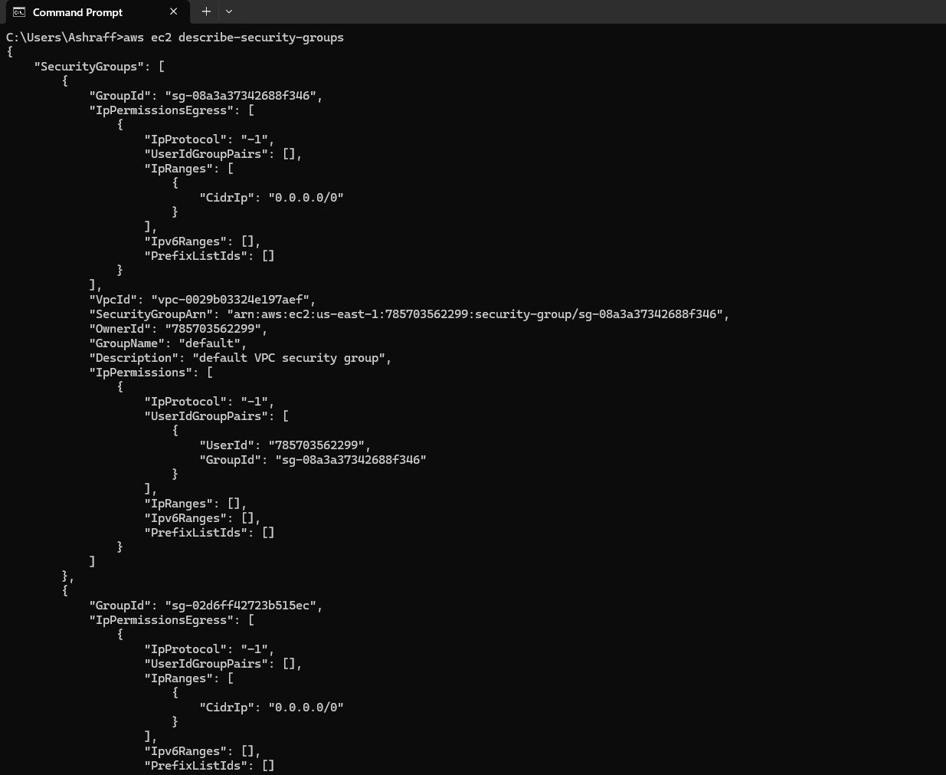
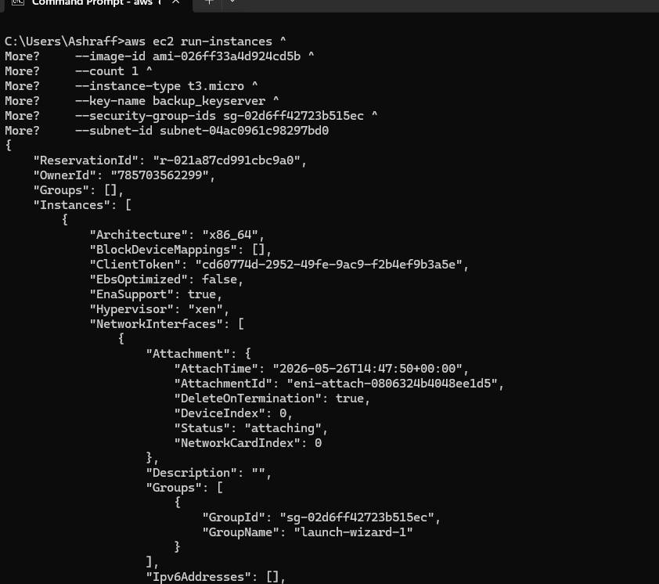
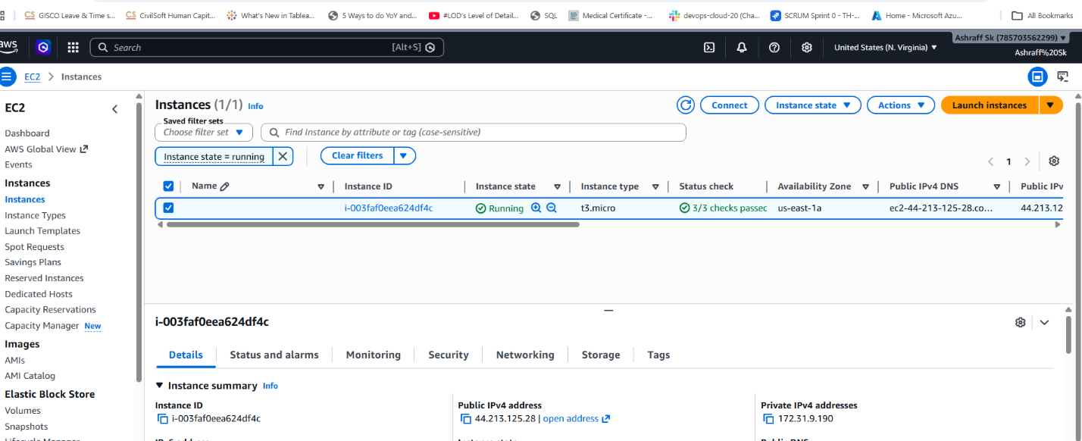

Purpose of AWS CLIs:
Automation and Scripting: The most significant advantage is the ability to create shell scripts (Bash, PowerShell) to perform repetitive tasks, such as stopping all Amazon EC2 instances at a specific time or bulk-uploading files to S3.
Direct API Access: It provides direct access to the public APIs of AWS services, allowing you to execute any function available in the browser console from your terminal.
Infrastructure Management: We can launch, list, modify, and terminate resources like EC2 instances using single commands (e.g., aws ec2 run-instances).
Faster Workflows: For power users, typing a command is often faster than navigating through multiple pages and menus in the graphical user interface (GUI).

